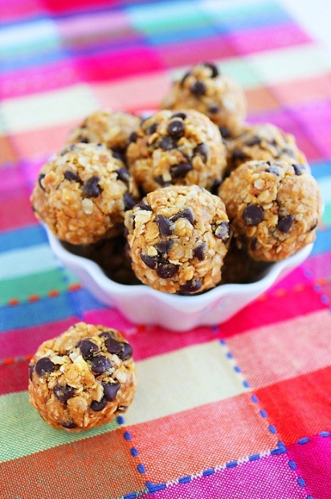
No-Bake Granola Energy Bites

INGREDIENTS
1 cup dry oatmeal (I used old-fashioned oats)
2/3 cup toasted coconut flakes
1/2 cup creamy peanut butter
1/2 cup ground flaxseed or wheat germ
1/3 cup honey
1 tsp. vanilla extract
1/2 cup mini chocolate chips, optional

DIRECTIONS
- Stir all ingredients together in a medium bowl until thoroughly mixed.
- Chill in refrigerator for half an hour.
- Once chilled, roll into balls of whatever size you would like. (about 1" in diameter.)
- Store in an airtight container and keep refrigerated for up to 1 week.
- Enjoy!

